|  |  |  |
| --- | --- | --- |
| New GRT Logo1 | **GRT INSTITUTE OF ENGINEERING ANDTECHNOLOGY,TIRUTTANI - 631209**  **ApprovedbyAICTE,NewDelhiAffiliatedtoAnnaUniversity,Chennai** |  |

#### DEPARTMENTOFCOMPUTERSCIENCEANDENGINEERING

**E-COMMERCE APPLICATION ON IBM CLOU D FOUNDARY**

**SUBMITTEDBY**

JYOTHESWAR T

3RD YEAR5THSEM

110321104056

[jyotheswarjyotheswar0@gmail.com](mailto:jyotheswarjyotheswar0@gmail.com)



# ANNAUNIVERSITY:CHENNAI 600025

## BONAFIDECERTIFICATE

Certified that this project report **“E-COMMERCE APPLICATION ON IBM CLOUDFOUNDARY”** is the bonafide work of **“JYOTHESWAR T [110321104056]”** who carriedouttheprojectworkundermyoursupervision.

#### SIGNATURE SIGNATURE

**Dr.N.KamalM.E.,Ph.D**., **Mr.T.A.VinayagamM.Tech.,**

#### HOD Assistantprofessor

DepartmentofComputerScienceAnd DepartmentofComputerScienceAnd

Engineering Engineering

GRT Instituteof Engineeringand GRT InstituteofEngineeringand

Technology Technology

Tiruttani Tiruttani

Certifiedthatthecandidates wereexaminedinViva- voceintheExaminationHeldon

**INTERNALEXAMINER EXTERNALEXAMINER**

## ACKNOWLEDGEMENT

WethankourManagementforprovidingusallsupporttocompletethisprojectsuccessfully.Our sincere thanks to honorable **Chairman**, **Shri. G. RAJENDRAN and Managing Director,Shri.G.R.RADHAKRISHNAN**forcreatingawonderfulatmosphereinside the campus.

Weareverygratefulto **Dr.S.ARUMUGAM,M.E.,Ph.D.,Principal**,forprovidinguswithconsistentguidanceandmotivationto executearealtimeprojecttolearnandexperiencetheprojectworkinanenvironments tocomplete ourprojectsuccessfully.

Oursincerethanksto **Dr.N.KAMAL,M.E.,Ph.D.,ProfessorandHead,DepartmentofComputer Science and Engineering** for giving me this wonderful opportunity to do the projectandprovidingthe requirefacilitiestofulfillourwork.

WearehighlyindebtedandthankfultoourprojectEvaluators**MrsV.PriyaM.E**.,and**Mrs. Edith Esther M.E.,Assistant Professor, Department of Computer Science andEngineering** forhisimmensesupportindoingthe project.

Wearevery grateful to ourinternal guide**Mr.T.A. VINAYAGAM, M.Tech.,AssistantProfessor, Department of Computer Science and Engineering** for guiding uswithhervaluablesuggestions tocompleteourproject.

We also dedicate equal and grateful acknowledgement to all the **respectable members ofthefaculty and lab in-charges** of the Department of Computer Science and Engineering, friendsandourfamiliesfortheirmotivation,encouragementand continuoussupport.

Our sincere thanks **to IBM and Skill Up Team members** for giving me this wonderfulopportunityto do theprojectand providingtherequire guidanceand valuable

|  |  |  |
| --- | --- | --- |
|  | **TABLEOFCONTENTS** |  |
| **CHAPTER**  **No** | **TITLE** | **PAGE**  **No** |
|  | **ABSTRACT** | 8  9  9  10  11  11  12  12  12  13 |
| **1.** | **PHASE1** |
|  | 1.0INTRODUCTION |
|  | 1.1PROBLEMDEFINITION |
|  | 1.2OBJECTIVES |
|  | 1.3DESIGN THINKING |
|  | 1.4SYSTEMDESIGNANDTHINKING |
|  | 1.5ARCHITECTURE |
| **2.** | **PHASE2** |
|  | * 1. PERSONALIZED STYLING APP   2. LOCAL ARTISAN MARKET PLACE   3. VIRTUAL FITTING ROOM |
|  | 2.4 FOOD DELIVERY PLATFORM |

|  |  |  |
| --- | --- | --- |
| **3.** | * 1. HOME INTERIOR DESIGN APP   2. CUSTOMIZED GIFT APP   3. **BLOCKCHAIN**   4. **DIGITAL STORE FRONTS**   5. **REMARKING**   6. **CONCLUSION**   **PHASE3**   * 1. INTRODUCTION   2. PROJECT DESIGN   3. PROCESS MODEL   4. USER INTERFACE DESIGN   5. IMPLEMENTATION TECHNOLOGIES   6. TRANSACTIONS IN THE APPLICATION   7. CONNECTING ASP.NET APPLICATION   8. THE SHOPPING CART APPLICATION   9. WEB BASED APPLICATION   10. DATA BASE CONNECTIVITY | 13  14  15  15  16  17  18  18  19  23  24  24  25  26  27  29 |

|  |  |  |
| --- | --- | --- |
| **4.** | **PHASE4**   * 1. :INTRODUCTION   2. PROJECT DESGIN   3. IMPLEMENTATION TECHNOLOGIS   4. SERVICES   5. WEB PAGE PROGRAMMING   6. CONCLUSION | 34  34  34  35  39  41 |

CHAPTER 1

PROJECTTITLE:**E-COMMERCE**

## ABSTRACT

E-commerce,theelectronic commerceindustry,hasreshapedtheglobalbusinesslandscape.Thisdigitalrevolution hasfundamentallyalteredthewayproductsandservicesareboughtandsold,transcen dinggeographicalboundariesandfosteringa new era of convenience and accessibility. This abstract provides a conciseexploration of the key facets of e- commerce, including online stores, digitalpayments, global reach, product diversity, convenience, personalization, security,logistics,andcustomerengagement.

In this digital age, businesses utilize e-commerce platforms to establish theironlinepresence,offeringcustomersanexpansiveselectionofgoodsandservices. Digital payment methods have replaced traditional cash transactions, enablingsecure and efficient online commerce. The global reach of e- commercetranscends borders, connecting businesses with a diverse and global customerbase. The convenience of 24/7 shopping and personalized productrecommendations enhances the customer experience, while robust securitymeasuressafeguardsensitiveinformation.

Efficient logistics and fulfillment strategies are crucial to meet customerexpectations for timely deliveries. Customer reviews and ratings empowershopperswithinformationtomake informedchoices,fosteringtrustinthedigitalmarketplace. As a dynamic and evolving industry, e-commerce presentsopportunities for businesses to thrive in an ever-changing landscape, fromstartups to established enterprises. The continued growth and innovation incommerce.

#### INTRODUCTION

E-commerce, short for "electronic commerce," is a rapidly growing businessmodel that involves buying and selling products or services over the internet. Ithas revolutionized the way people shop and conduct business by eliminatinggeographicalbarriersandprovidingconvenience,accessibility,andawide rangeofoptionsto bothconsumersandbusinesses.

Keyelementsofe-commerceinclude:

**OnlineStores:**E- commercereliesonwebsitesormobileappswherebusinessesshowcase their products or services. These digital storefronts are accessible toanyonewithaninternetconnection.

**Digital Payments**: E-commerce transactions often involve electronic payments,suchascreditcards,digitalwallets(e.g.,PayPal,ApplePay),andcryptocurren cies.

**GlobalReach**:E- commerceallowsbusinessestoreachcustomersworldwide,expandingtheirmarketb eyondphysicalboundaries.

**Product Variety**: E-commerce platforms offer a vast array of products andservices,fromphysicalgoodslikeclothingandelectronicstodigitalproductslikesoft wareande-books.

## PROBLEMDEFINATION

Theterm"e-commerce"referstoelectroniccommerce,whichinvolvesbuyingand selling goods or services over the internet. An e-commerce problem canencompass a wide range of challenges and issues related to online businessoperations.Somecommonproblemareasine-commerceinclude:

**WebsitePerformance**:Slowloadingtimes,website downtime,andtechnicalglitchescanleadto apooruserexperience andlostsales.

**Security**:Protectingcustomerdataandpaymentinformationfromcyberthreatsandda tabreachesis crucialine-commerce.

**PaymentProcessing**:Issueswithpaymentgateways,fraudprevention,andtrans actionerrorscandisruptthebuyingprocess.

**InventoryManagement**:Balancingsupplyanddemand,trackinginventorylevels,and avoidingoverstockorstockoutscanbechallenging.

**CustomerService**:Providingresponsiveandhelpfulcustomersupportisvitalforaddressingcus tomerinquiriesandresolvingissues.

**UserExperience**:Ensuringauser-friendlyandintuitive websitedesignandnavigationisessentialforconversionandcustomerretention

.

**IncreaseSales**:Togeneraterevenueandgrowthebusinessbyincreasingonlinesales.

## OBJECTIVES

**IncreaseSales**:Togeneraterevenueandgrowthebusinessbyincreasingonlinesales.

**ExpandCustomerBase**:Toreachandacquirenewcustomersthroughonlinechannels.

**ImproveCustomer Experience**:Toenhancetheuser experienceonthewebsiteorapp, makingit easyforcustomerstofindand purchaseproducts.

**BuildBrandAwareness**:Toestablishandstrengthenthebrand'spresenceintheonline market.

**ReduceCartAbandonment**:Tominimizethenumberofcustomerswhoabandontheirs hoppingcartswithoutcompletinga purchase.

**OptimizeConversionRate**:Toimprovethepercentageofvisitorswhomakeapurchase.

**EnhanceProductOfferings**:Tocontinuouslyupdateandexpandtheproductcatalogto meetcustomerneeds.

**StreamlineOperations**:Toimproveefficiencyinorderfulfillment,inventorymanagement,an dcustomersupport.

**CompetitivePricing:**Tooffercompetitivepricesandpromotionstoattractandretaincu stomers.

## DESIGNTHINKING

**SYSTEMARCHITECTURE**

A system architecture is the conceptual model that defines thestructure, behavior, and more views of a system. An architecturedescription is a formal description and representation of a system,organizedinawaythatsupportsreasoningaboutthestructures andbehaviorsofthesystem

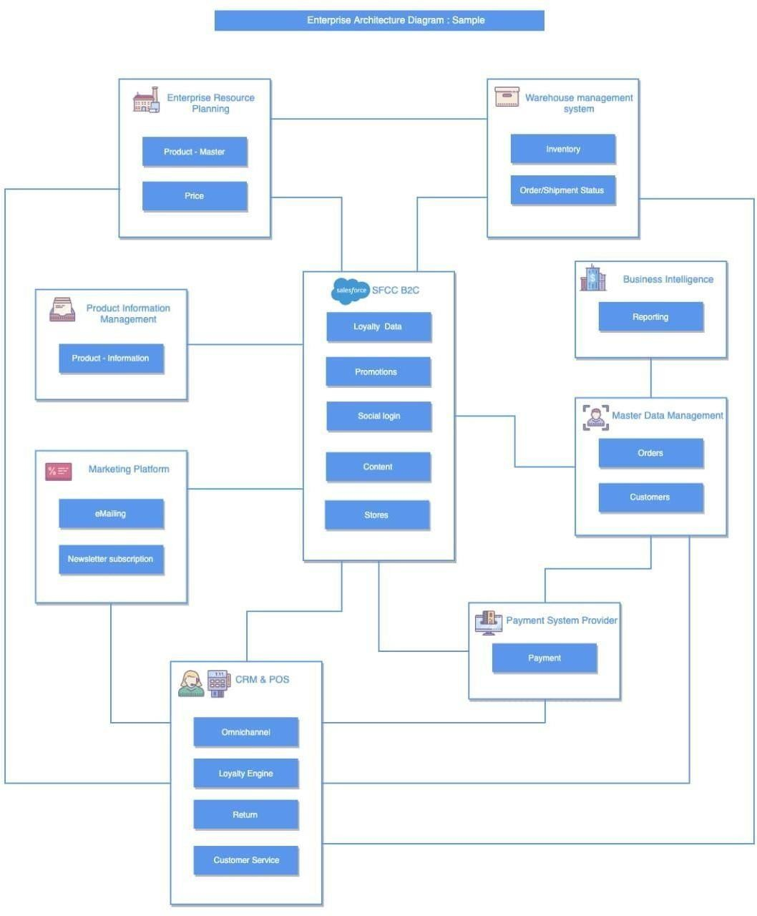

#### CHAPTER 2

**Topic:Innovation**

#### Considerincorporatingfeatureslikeproductreviews,wishlists,andpersonalize d recommendations to enhance user engagement andsatisfaction.

**Abstract**

#### In today’s digital age, ecommerce apps have transformed the way we shopand interact with businesses. From personalized recommendations tovirtualtry- onexperiences,theseappsofferconvenience,accessibility,andaseamless shopping experience. In this blog post, we will explore 10innovative ecommerce app ideas that have the potential to revolutionizeonlineshopping.Let’s

**divein!**

#### :PersonalizedStylingApp:

**Imagineanappthatactsasyourpersonalstylist,offeringtailoredfashionrecomm endations based on your preferences, body type, and currentfashion trends. Users can browse and purchase clothing items directlythroughtheapp,savingtimeandenhancingtheirshoppingexperience.**

#### :LocalArtisanMarketplace:

**Supporting local artisans and craftsmen is essential for preservingtraditional craftsmanship and promoting unique products. An app thatconnects users with local artisans can provide a platform for them toshowcaseandselltheirhandmadeproducts,enablingcustomerstodiscoverand purchaseone-of-a-kind items.**

#### :VirtualFittingRoom:

**One of the challenges of online shopping is not being able to try on itemsbefore purchasing. A virtual fitting room app addresses this issue byutilizing augmented reality (AR) technology. Users can virtually try onclothes,accessories,orevenmakeupproducts,helpingthemmakeinformedpu rchasingdecisions.**

12

#### :SustainableProductsMarketplace:

**commerceindustry,hasreshapedtheglobalbusinesslandscape.Thisd igitalrevolutionhasfundamentallyalteredthewayproductsandservi cesareboughtandsold,transcendinggeographicalboundariesandfos teringa new era of convenience and accessibility. This abstract provides a conciseexploration of the key facets of e-commerce, including online stores, digitalpayments, global reach, product diversity, convenience, personalization, security,logistics,andcustomerengagement.**

#### In this digital age, businesses utilize e-commerce platforms to establish theironlinepresence,offeringcustomersanexpansiveselectionofgo odsandservices.Digital payment methods have replaced traditional cash transactions, enablingsecure and efficient online commerce. The global reach of e-commercetranscends borders, connecting businesses with a diverse and global customerbase.

**The convenience of 24/7 shopping and personalized productrecommendations enhances the customer experience, while robust securitymeasuressafeguardsensitiveinformation.**

#### Efficient logistics and fulfillment strategies are crucial to meet customerexpectations for timely deliveries. Customer reviews and ratings empowershopperswithinformationtomake informedchoices,fosteringtrustinthedigitalmarketplace. As a dynamic and evolving industry, e-commerce

**presentsopportunities for businesses to thrive in an ever-changing landscape, fromstartups to established enterprises. The**

#### continued growth and innovation incommerce.

13

#### With an increasing focus on sustainability and ethical consumption, anecommerce app that exclusively features eco-friendly and sustainableproductsishighlyvaluable.Userscanexploreandpurchaseitemsthatal ignwiththeirvalues,supporting environmentallyconsciousbusinesses.

1. **:FoodDeliveryPlatform:**

#### Food delivery apps have gained immense popularity, but there’s alwaysroom for innovation. An app that connects users with local restaurants,provides an intuitive ordering interface, and offers seamless deliverytrackingcanenhancethefoodorderingexperienceandsimplifythe processforbothcustomersandrestaurants.

1. **:SecondhandGoodsMarketplace:**

#### Promoting the reuse and recycling of goods is crucial for reducing wasteand extending the lifecycle of products. An app that facilitates the buyingand selling of used items can create a vibrant marketplace where users canfindgreatdealsonpre- ownedgoodswhilepromotingasustainablelifestyle.

1. **:BeautySubscriptionService:**

#### Subscription services have gained significant traction in various industries,andbeautyisnoexception.Anappthatoffersabeautysubscriptionser vicecan curate personalized beauty product recommendations for users basedon their preferences, allowing them to discover new products and enjoyconvenientdeliveries.

1. **:HomeInteriorDesign App:**

#### Decorating a home can be a daunting task, but an app that simplifies theprocess can be a game-changer. Users can explore a wide range of furnitureand decor items,virtuallyvisualizethemin their spaceusing AR technology,and make purchases directly through the app, revolutionizing the homeinteriordesignexperience.

1. **:PetSuppliesandServicesApp:**

#### Petsareanintegralpart of manyhouseholds,andanappcateringtopetowners can provide a centralized platform for their needs. From petsuppliestogroomingservicesandevenveterinaryappointmentbooking,

14

#### thisappcanofferconvenienceandpersonalizedrecommendationsforpetcare. 10 :CustomizedGiftApp:

**Finding the perfect gift for a loved one can be challenging, but an appspecializing in customized and personalized gifts can make it easier. Userscanbrowsethroughavarietyofoptions,personalizetheirchosenitems,andh ave them delivered directly to the recipient, ensuring a memorable anduniquegiftingexperience.**

#### :SuperFastDeliveryandInstantPickupCounters

**Superfastdeliveryandinstantpickupcountersareinnovativee- commercesolutionsthatofferarange ofbenefitsforbothretailersandcustomers. Here’showitaccomplishesits**

#### Convenience:Superfast deliveryandinstantpickupcountersallowcustomerstoreceivetheirordersquickl yandconveniently.

**Speed:Withsuperfastdelivery,customerscanreceivetheirordersinaslittle as a few hours, while instant pickup counters allow customers tocollect their orders in minutes. This is particularly useful for customersneedingtime-sensitiveitems.**

#### Competitiveadvantage:Offeringperkslikesuper-fastdeliveryandinstantpickup can differentiate retailers from their competitors and increasecustomerloyalty,givingyourbrandacompetitiveadvantage.

1. **:ShoppingusingARTechnology**

#### Recent estimates from industry experts like Global Newswire indicate thattheaugmentedrealitybusinessisboomingandexpandingfasterthannearlya ny other technology. By 2030, the AR market is projected to increase at aCAGRofaround41.5%,reachingavalueofabout$461.25 billion.

**Here’showshoppingusingARtechnologyisbeneficial–**

⦁

#### Enablescustomerstovisualizeproductsusingtheirsmartphonesortabl etsina real-worldenvironment.

⦁ **Retailers can use AR technologyto showcasetheirproductsmoreengaginglyandinteractivelyanddifferentiatethem selvesfromcompetitors.**

#### ⦁ ARtechnologycanalsohelpreducereturnrates, ascustomerscanseehowproductslookandfit beforepurchasing.

15

#### ⦁ Shopping using AR technology is an emerging trend in e- commercethathasthepotentialtorevolutionizethewaycustomersshopandint eractwithretailers.

1. **:Blockchain**

#### At a compound annual growth rate (CAGR) of 87.8%, the worldwideblockchaininretailmarketsizeincreasedfrom$0.88 billionin2022to$1.64billion in 2023. Blockchain technology has the potential to revolutionize e-commerceinthefollowingways–

⦁

#### Securepayments:Blockchaincanenablesecureandefficientpaymentpro cessing for e-commerce transactions, reducing the risk of fraud andchargebacks.

⦁ **Transparency and accountability: Blockchain can provide atransparentandtamper- proofrecordofalltransactions,increasingtrustandaccountability for buyersandsellers.**

#### ⦁ Supply chain management: Blockchain can enable greatertransparencyandtraceabilityinsupplychainmanagement,allo wingretailers and consumers to track the journey of products from themanufacturertotheenduser.

⦁ **Decentralized marketplaces: Blockchain-based marketplaces canenablethe decentralizedbuying andsellingofgoodsandservices. As aresult,itcancreatemoreopportunitiesforsmallbusinessesandreducethepow erofcentralizedintermediaries.**

#### DigitalStorefronts

**Anelectronicvisualrepresentationofabrandandcompanyisknownasa“digit al storefront,” It replicates the physical attributes that provide apersonalized experience and sustain a personal connection like the usualbrick-and-mortaroutlets.**

#### A digital storefront comprises features like productlistings,pictures,descriptions,costs,anduserreviews.Digitalstorefrontse nablebusinessestoreach a wider audience, expand their customer base, and generate salesonline. They are a key component of e-commerce and are essential forbusinessesthatwanttosucceedinthecompetitiveonlinemarketplace.

16

#### Remarketing

**Remarketing is a powerful tool for e-commerce innovation that allows youtotargetcustomerswhohavepreviouslyshowninterestinyourproductsorse rvices.Withthehelpofremarketing,businesses can-**

⦁

#### Increaseconversionsandimproveyourreturnoninvestment(ROI)byd isplayingtargetedadstothesecustomers.

⦁

#### Enablesyourbrandtostayrelevantamongpotentialcustomers,rem indingthemof yourbrandandencouraging themtopurchase.

⦁

#### Providesvaluableinsightsintocustomerbehavior,allowingyoutotail or your marketing messages and improve your overall e- commercestrategy.

1. **WebsiteAnalytics**

#### This a great innovation in e-commerce! Website analytics is essential for e- commerce innovation, providing valuable insights into customer behaviorandpreferences.Analyzingcustomerbehavioronyourwebsitewillhelp youbetter understand how your audience interacts with your products andservices. The pages they visit most often, and the factors influencing theirdecision. Just 2 visitors out of every 100 who visit a website will convert,accordingtotheaverageconversionrate,whichis2.35%.

**Thisinformationcanhelpyoumakedata-drivendecisionsaboutyoure- commerce strategy, such as optimizing your website layout or adjustingyourmarketingmessagingtobetterappealtoyourtargetaudience.**

#### E-wallet technologyisamust.

**Ewallet technology offers numerous benefits for e-commerce innovation,providing customers with a convenient and secure way to purchase online.Withe- wallets,customerscanstoretheirpaymentinformationinoneplace,makingthech eckoutprocessfasterandmorestreamlined.**

#### With the global e-wallet market expected to reach $3 trillion by 2024,incorporating this innovative payment solution into your e- commercestrategywilllet youextendbetter customerservices.

1. **Mobiledominatesonlinesales.**

17

#### Mobiledeviceshavebecometheprimarywaypeopleaccesstheintern etandpurchaseonline.Withtheconvenienceofbeingabletoshopfro manywhere,commerceindustry,hasreshapedtheglobalbusinesslan dscape.Thisdigitalrevolutionhasfundamentallyalteredthewayprod uctsandservicesareboughtandsold,transcendinggeographicalboun dariesandfosteringa new era of convenience and accessibility.

**This abstract provides a conciseexploration of the key facets of e- commerce, including online stores, digitalpayments, global reach, product diversity, convenience, personalization, security,logistics,andcustomerengagement.**

#### In this digital age, businesses utilize e-commerce platforms to establish theironlinepresence,offeringcustomersanexpansiveselectionofgo odsandservices.Digital payment methods have replaced traditional cash transactions, enablingsecure and efficient online commerce. The global reach of e-commercetranscends borders, connecting businesses with a diverse and global customerbase.

**The convenience of 24/7 shopping and personalized productrecommendations enhances the customer experience, while robust securitymeasuressafeguardsensitiveinformation.**

#### Efficient logistics and fulfillment strategies are crucial to meet customerexpectations for timely deliveries. Customer reviews and ratings empowershopperswithinformationtomake informedchoices,fosteringtrustinthedigitalmarketplace. As a dynamic and evolving industry, e-commerce

**presentsopportunities for businesses to thrive in an ever-changing landscape, fromstartups to established enterprises. The**

#### continued growth and innovation incommerce.

18

#### atanytime,mobile hasquicklybecomethedominantplatformforonlinesales.

**Infact,accordingtorecentstudies,mobiledevicesaccountforover60%ofall e- commerce traffic, and that number is only expected to grow in thecoming years. With the ability to shop on the go, compare prices, and readreviews inreal-time,mobilehas revolutionizedhowpeopleshoponline.**

#### Businesses

**thatfailtoprioritizemobileoptimizationriskbeingleftbehindintoday’sincreasi nglymobile-firstworld.**

#### Conclusion:

**Astechnologycontinuestoadvance,ecommerceappshavethepotentialtoreshap ethe wayweshopandinteractwithbusinesses.These10innovativeecommerce app ideas highlight the possibilities for creating seamless,personalized, and sustainable shopping experiences. By embracing theseideas, entrepreneurs can tap into the evolving consumer preferences andrevolutionizetheworldofonlineshopping.**

19

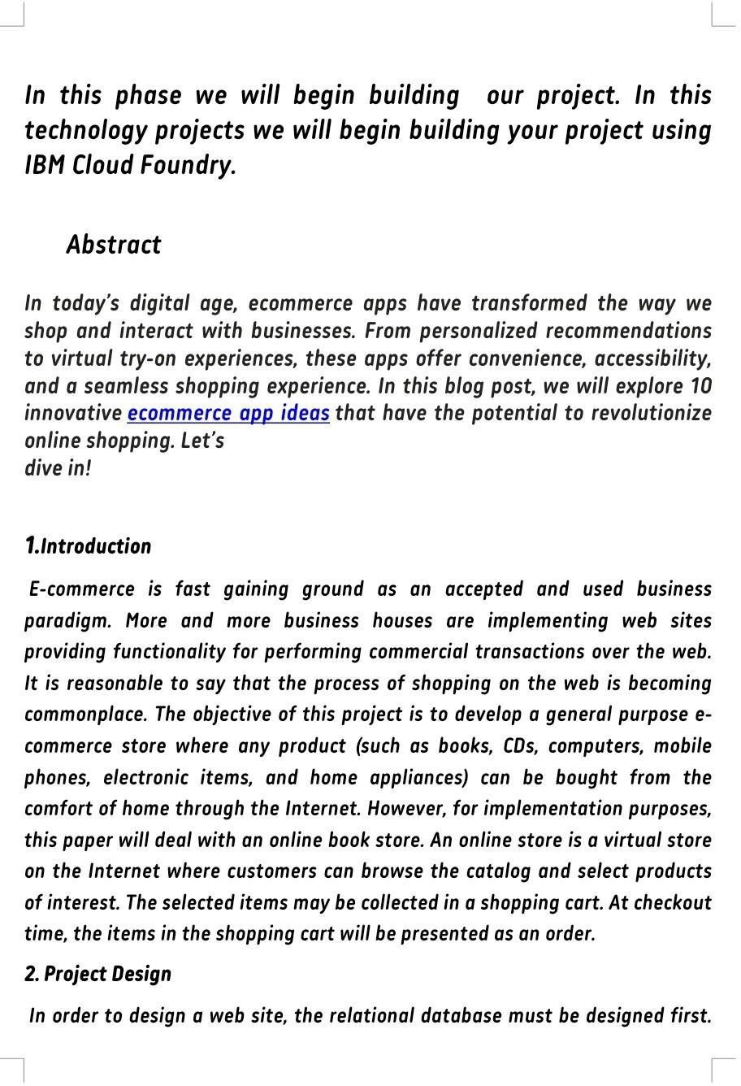

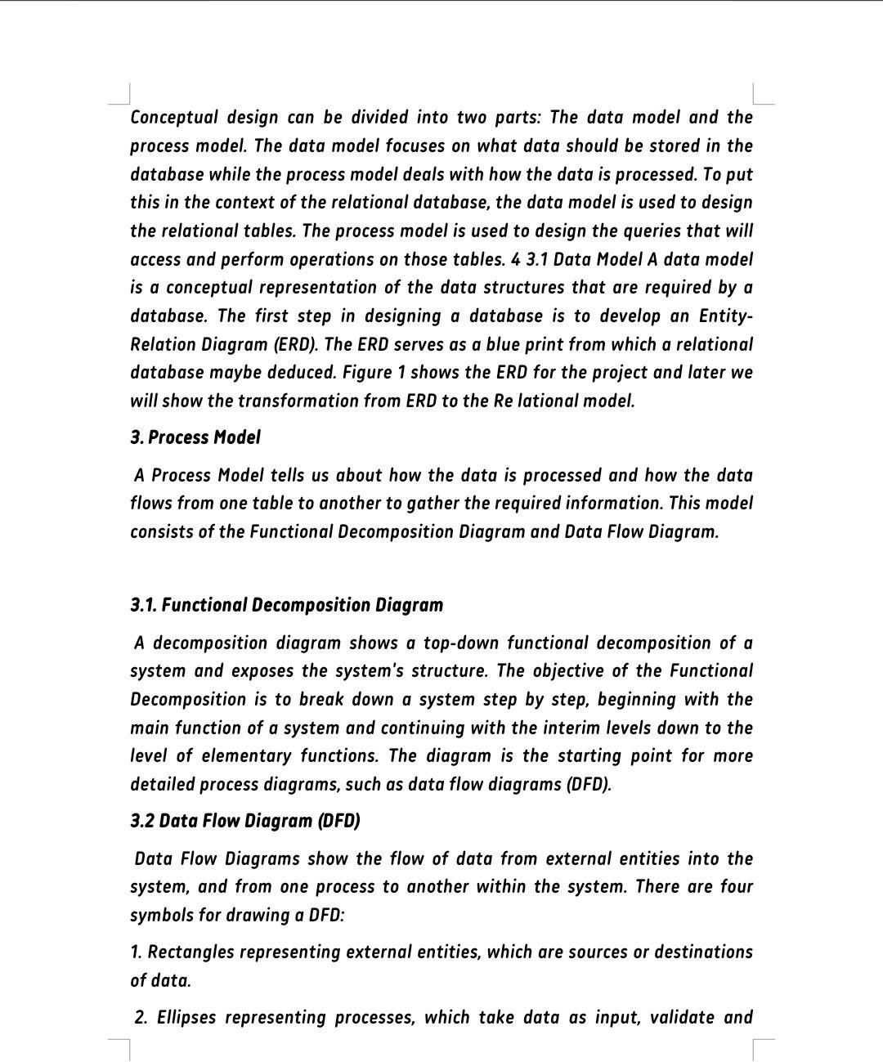

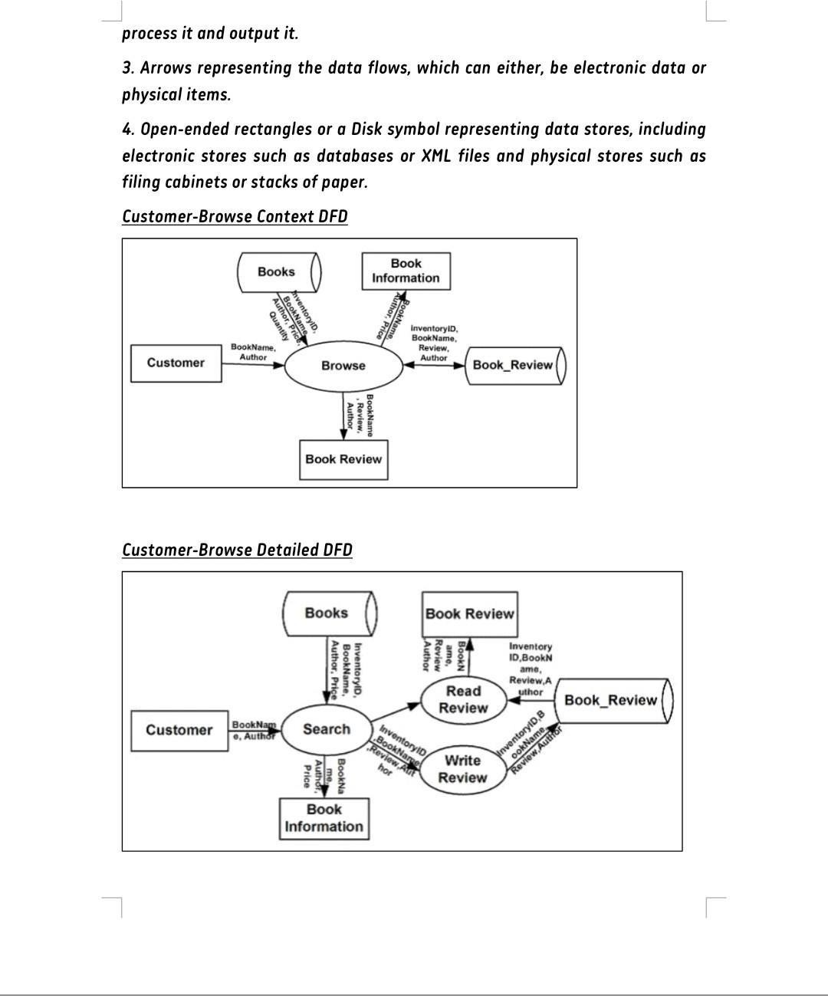

22

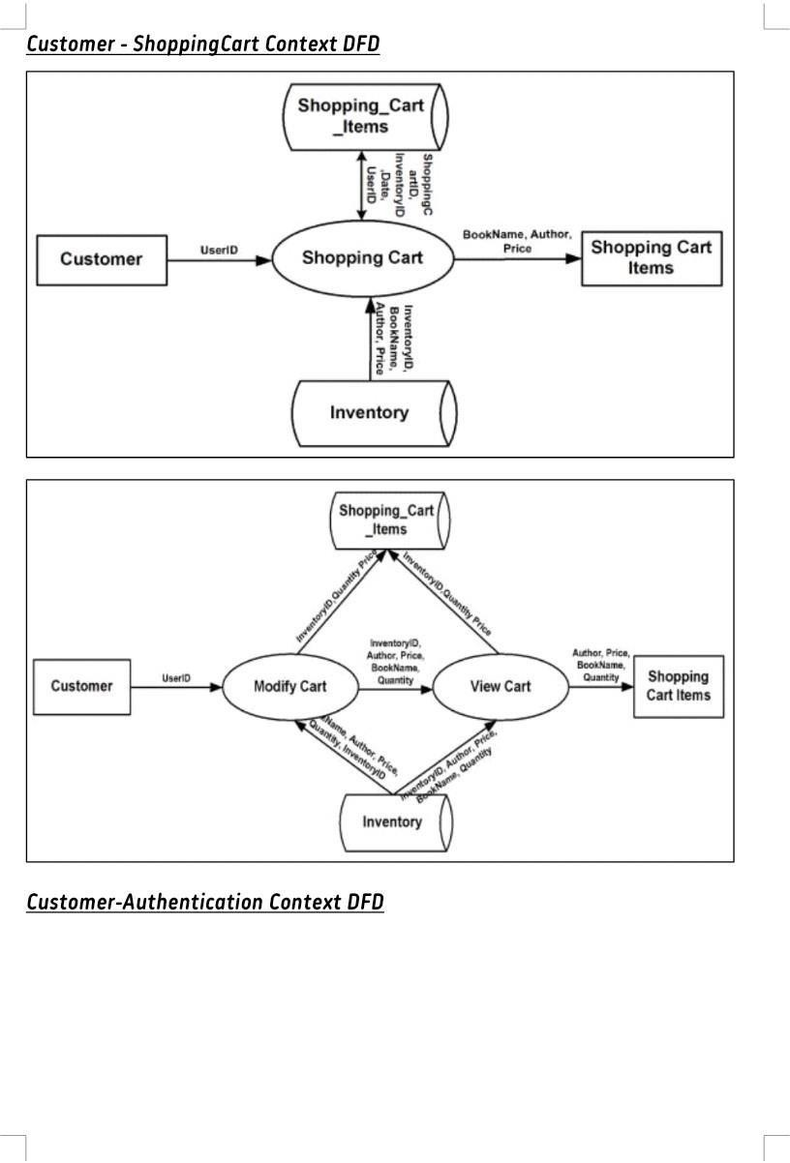

23

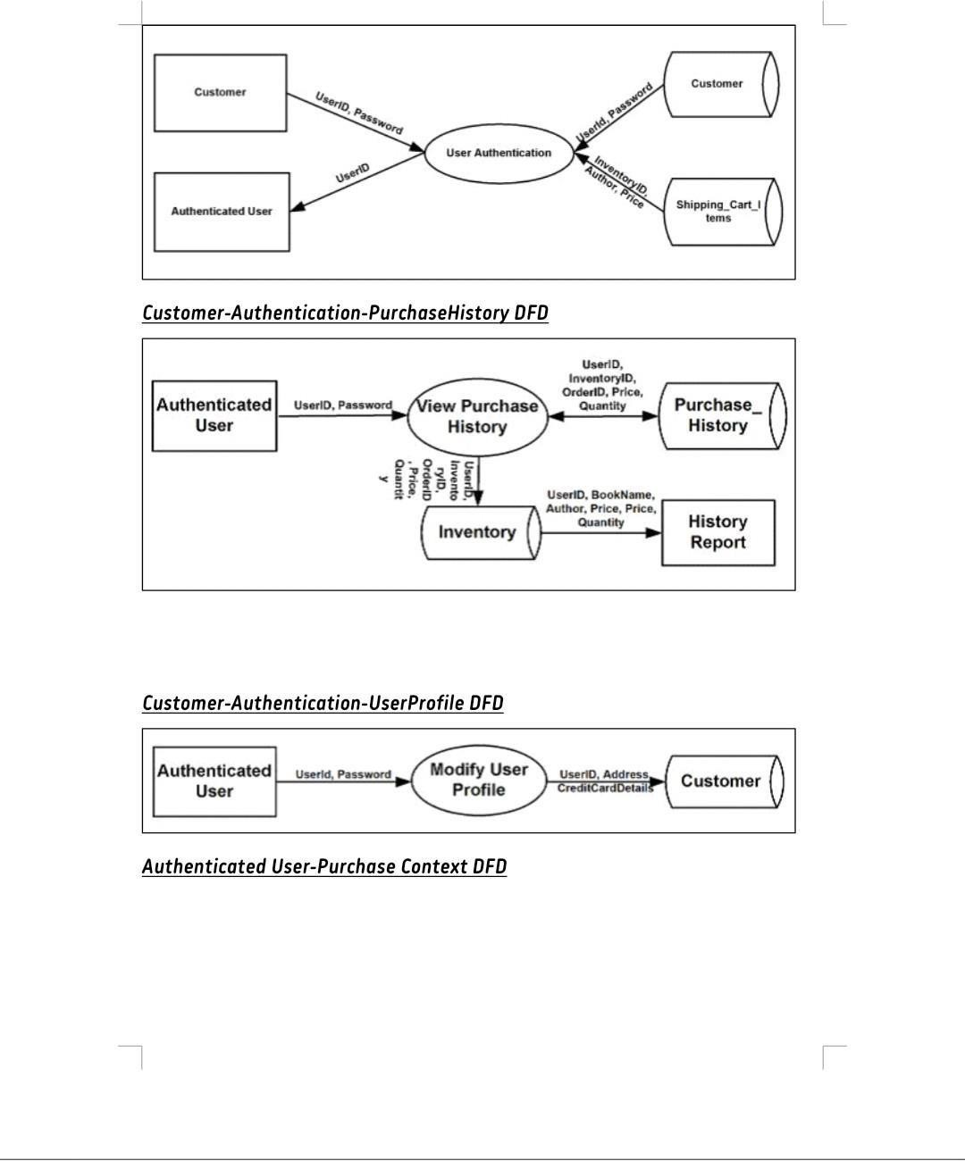

24

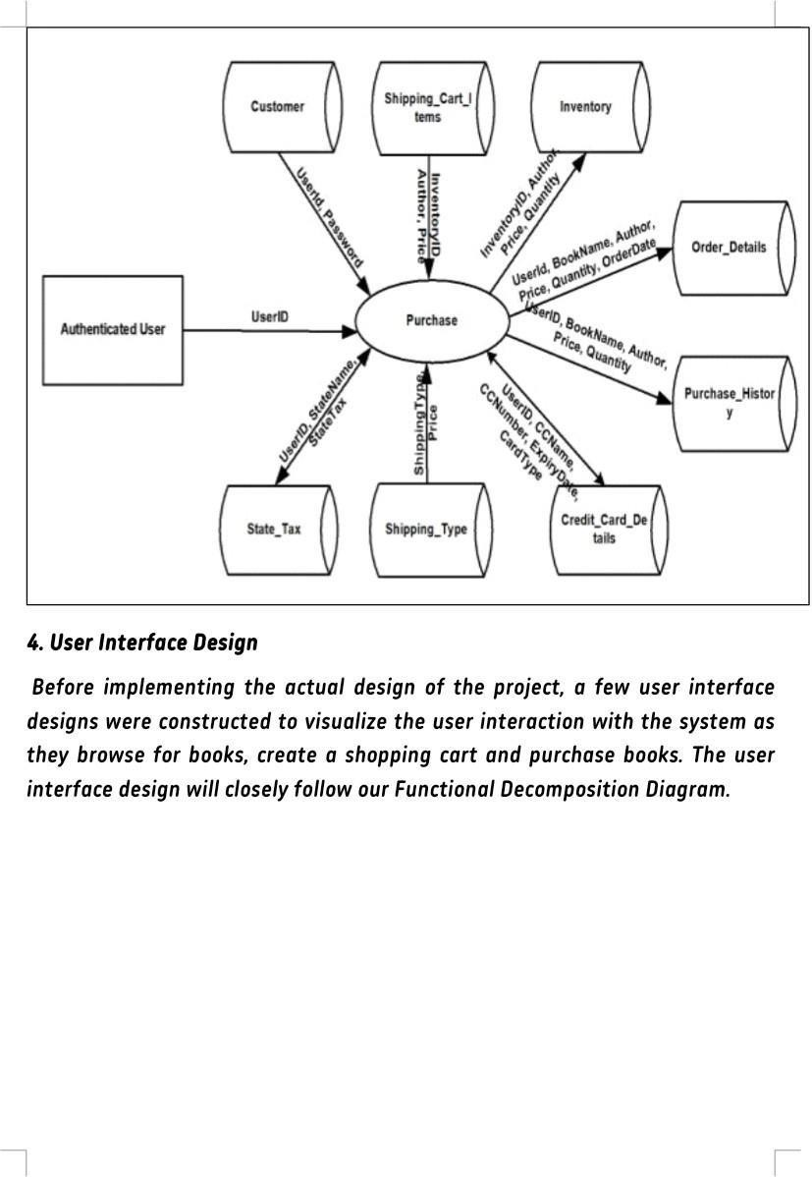

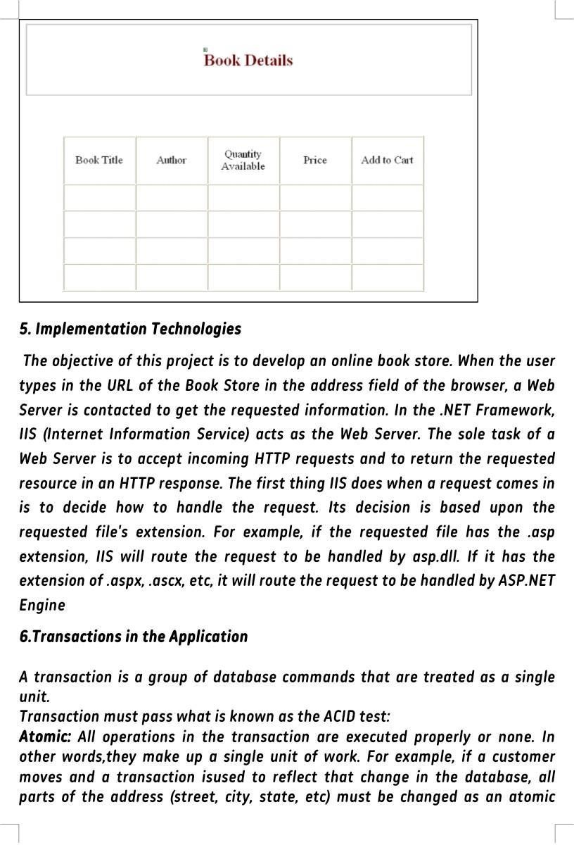

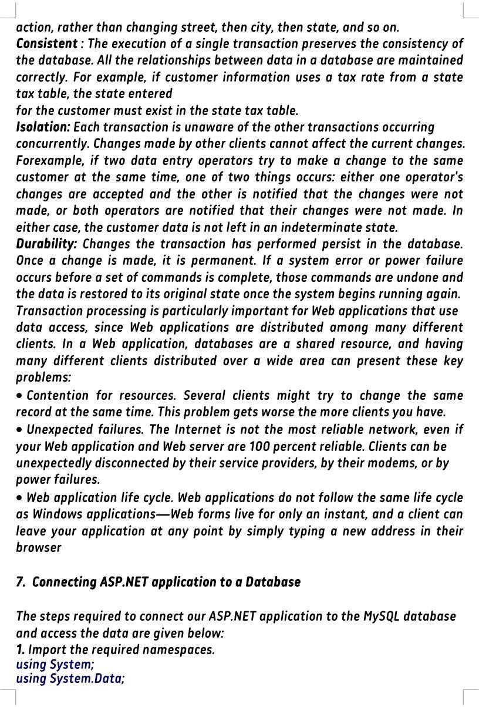

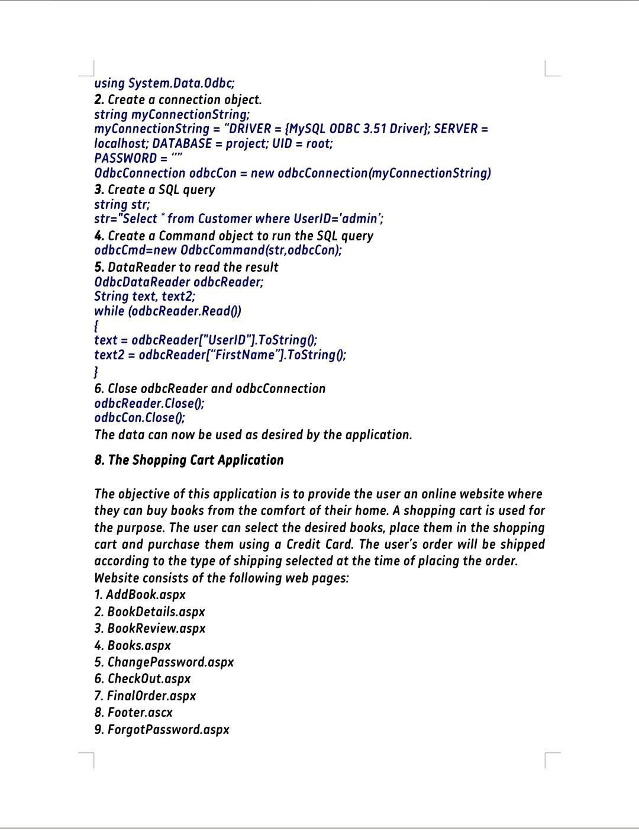

28

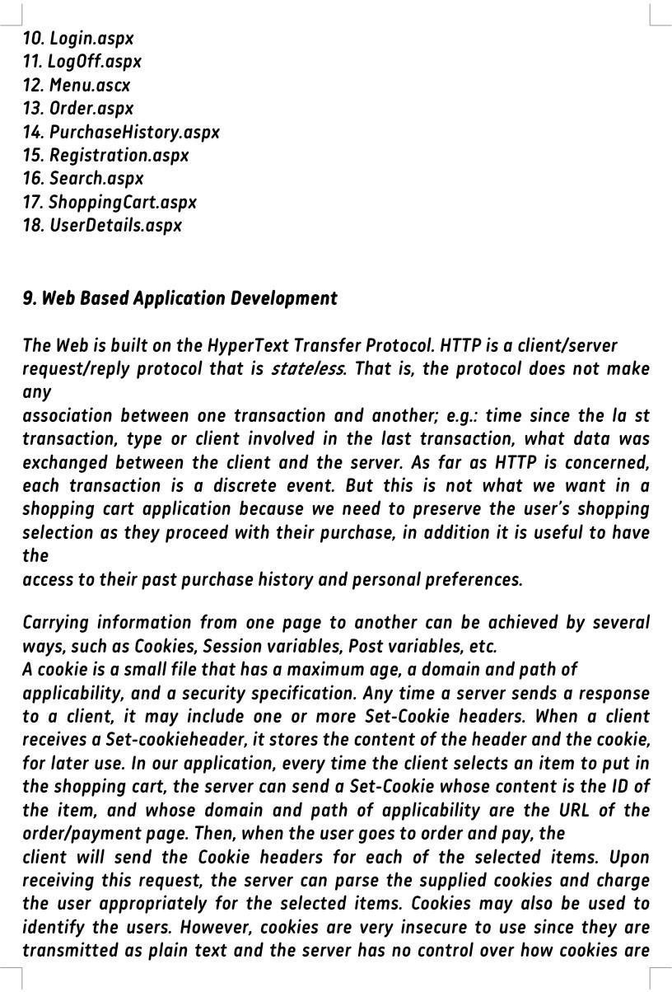

29

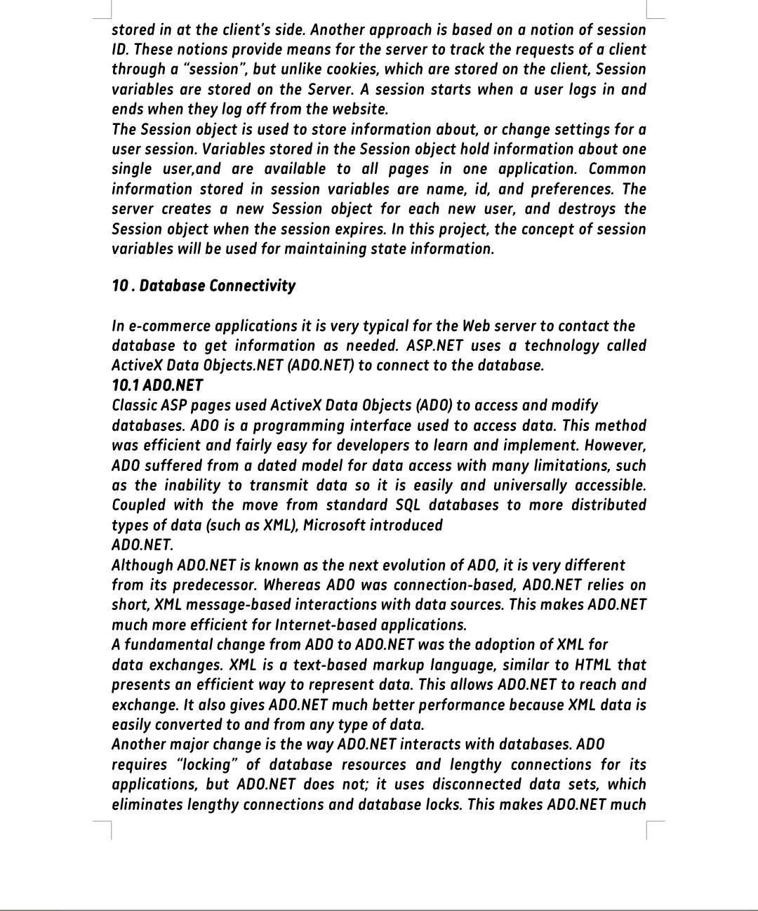

30

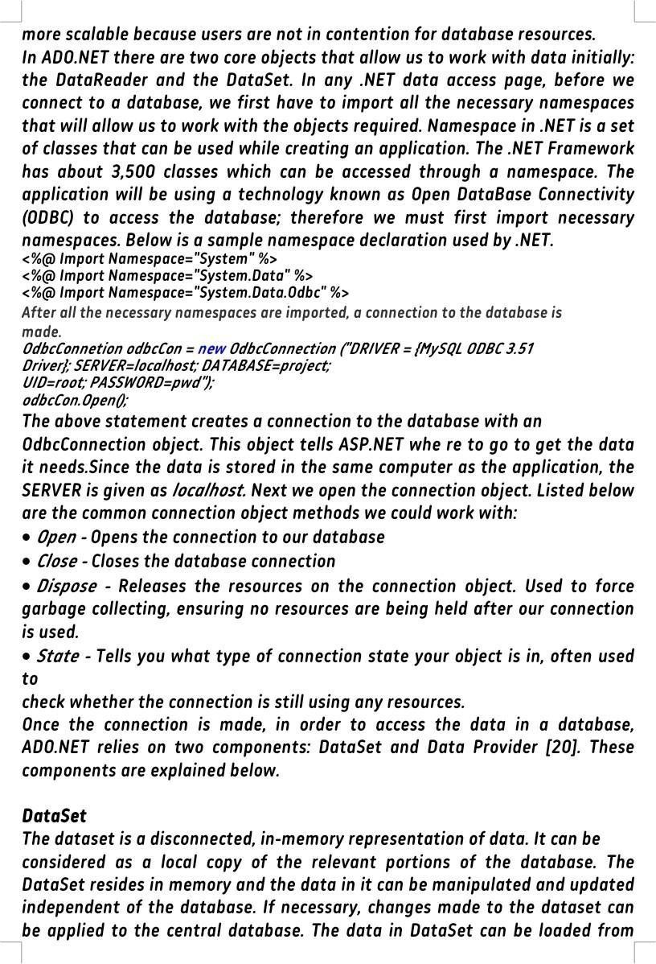

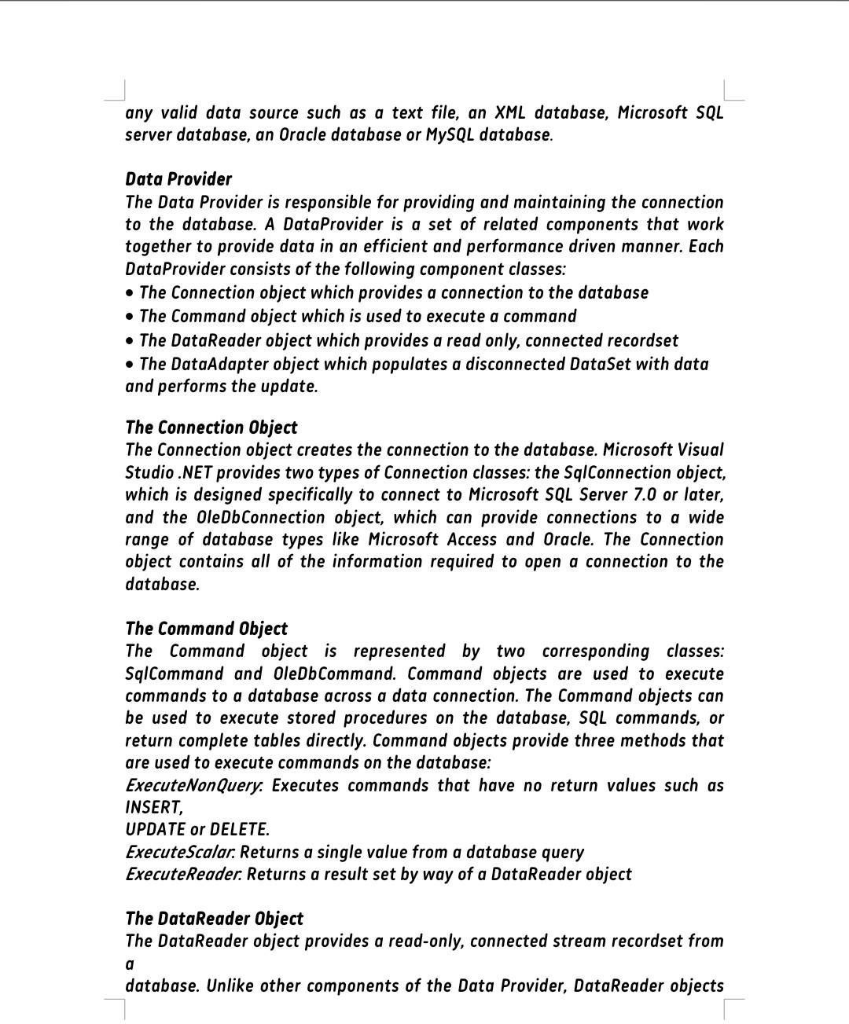

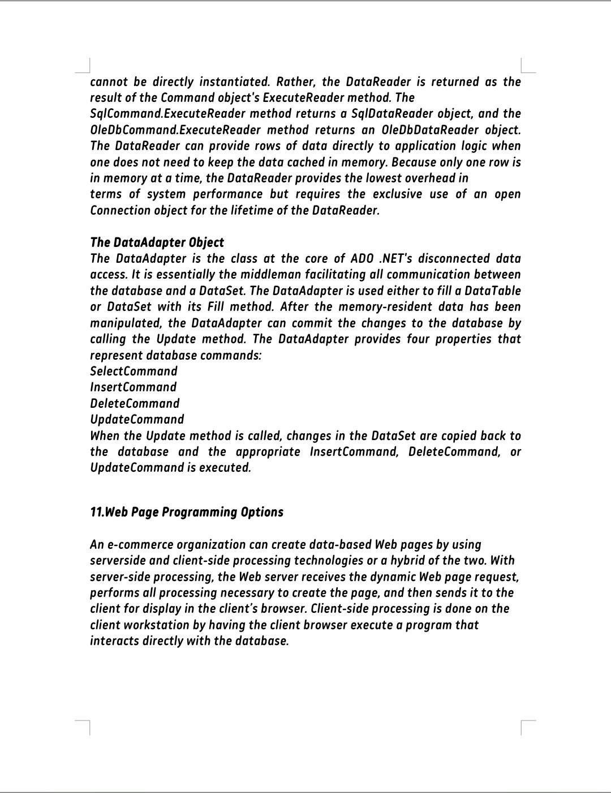

33

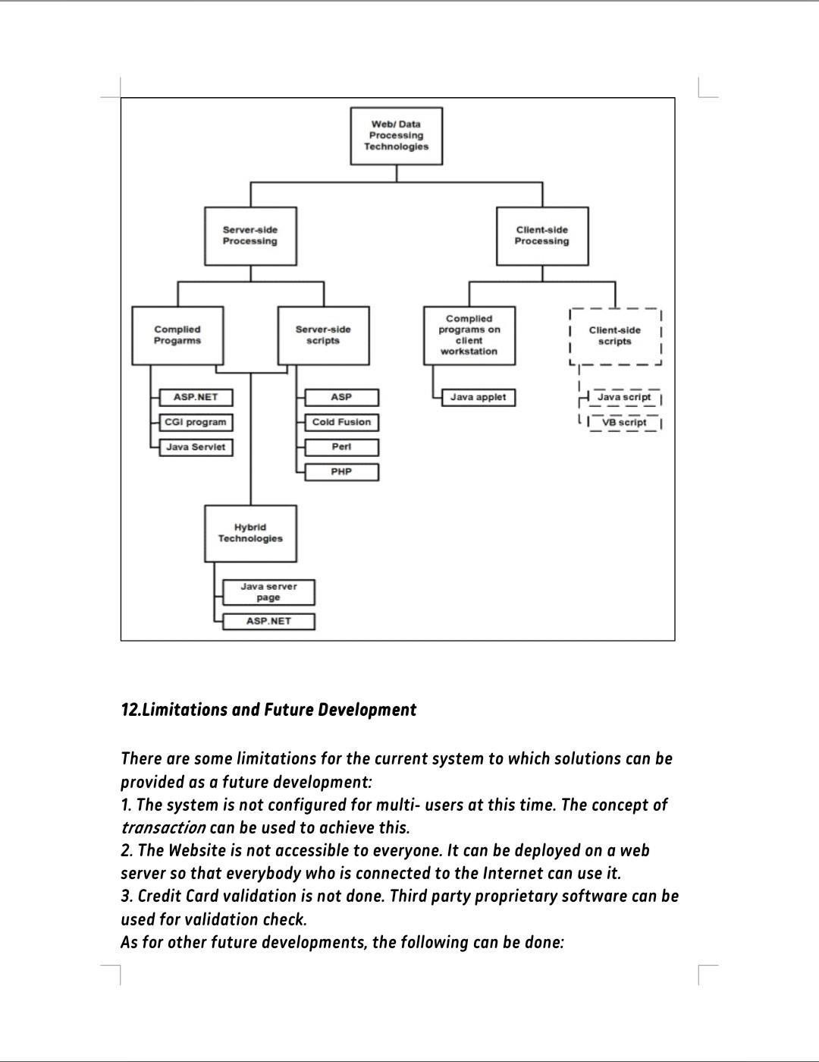

34

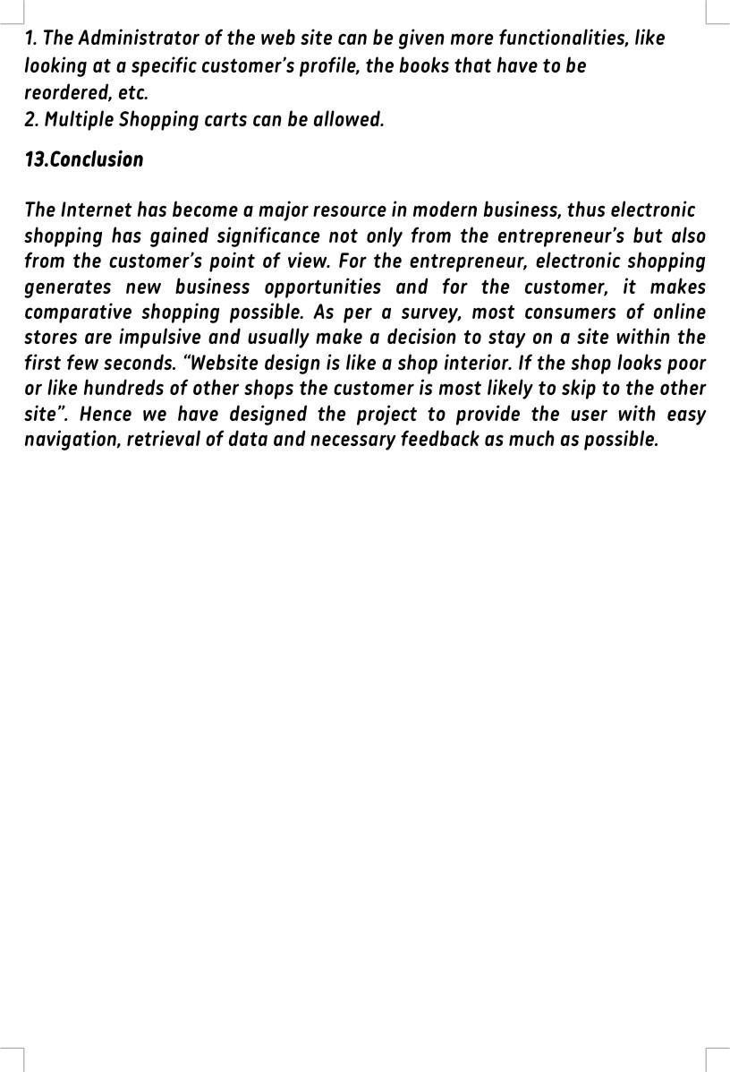

35

# CHAPTER 4

**Abstract**

### Intoday’sdigitalage,ecommerceappshavetransformedthewayweshop and interact with businesses. From

personalizedrecommendationstovirtualtry- onexperiences,theseappsofferconvenience,accessibility,andaseamles sshoppingexperience.Inthis blog post, we will

### explore 10 innovative[ecommerce appideas](https://www.wdptechnologies.com/top-ecommerce-app-ideas/)that have the potential to revolutionize online shopping. Let’sdivein!

#### Introduction

E-

commerceisfastgaininggroundasanacceptedandusedbusinessparadigm.Morean dmorebusinesshousesareimplementingwebsitesprovidingfunctionalityforperfo rmingcommercialtransactionsovertheweb.Itisreasonabletosaythattheprocessof shoppingonthewebisbecomingcommonplace. The objective of this project is to develop a general purpose e-commerce store where any product (such as books, CDs, computers, mobilephones, electronicitems, and homeappliances) can bebought fromthecomfortof home through the Internet. However, for implementation purposes, thispaper will deal with an online book store. An online store is a virtual store onthe Internet where customers can browse the catalog and select products ofinterest. The selected items may be collected in a shopping cart. At checkouttime,theitemsin theshoppingcart willbepresentedas anorder.

#### ProjectDesign

In order to design a web site, the relational database must be designed first.Conceptual design can be divided intotwo parts: The data model and theprocess model. The data model focuses on what data should be stored in thedatabase while the process model deals with how the data is processed. To putthis in the context of the relational database, the data model is used to designthe relational tables. The process model is used to design the queries that willaccessandperformoperations onthosetables.

#### ImplementationTechnologies

The objective of this project is to develop an online book store. When the usertypes in the URL of the Book Store in the address field of the browser, a WebServeriscontactedtogettherequestedinformation.Inthe.NETFramework,IIS( Internet Information Service) acts as the Web Server. The sole task of a WebServer isto accept incoming HTTP requestsand to return the requested resourcein an HTTP response. The first thing IIS does when a request comes in is to decidehow to handle the request. Its decision is based upon the requested file'sextension.Forexample,iftherequestedfilehasthe.aspextension,IISwillroutet herequesttobehandledbyasp.dll.Ifithastheextensionof.aspx,.ascx,etc,itwillroute therequest to behandledbyASP.NETEngine.

The ASP.NET Engine then gets the requested file, and if necessary contacts thedatabasethroughADO.NETfortherequiredfileandthentheinformationissentba ck to the Client’s browser.how a client browser interacts with the Web serverand howtheWebserverhandlestherequestfromclient.

#### Services

* 1. **InternetInformationServices (IIS)**

IISisasetofInternetbasedservicesforWindowsmachines.Originallysuppliedas part of the Option Pack for Windows NT, they were subsequently integratedwith Windows 2000 and Windows Server 2003). The current (Windows 2003)versionisIIS6.0andincludesserversforFTP(asoftwarestandardfortransferrin g computer files between machines with widely different operatingsystems), SMTP (Simple Mail Transfer Protocol, is the de facto standard for emailtransmission across the Internet) and HTTP/HTTPS (is the secure version ofHTTP, thecommunicationprotocolof theWorldWideWeb).

Features: The web server itself cannot directly perform server side processingbut can delegate the task to ISAPI (Application Programming Interface of

IIS)applicationsontheserver.Microsoftprovidesanumberoftheseincludingonesfo rActiveServerPageandASP.NET.Compatibility:InternetInformationServicesis designed to run on Windows server operating systems. A restricted versionthatsupportsonewebsiteandalimitednumberofconnectionsisalsosupplie

dwithWindowsXPProfessional.Microsofthasalsochangedtheserveraccount

that IIS runs on. In versions of IIS before 6.0, all the features were run on theSystemaccount,allowingexploitstorunwildonthesystem.Under6.0manyofthe processes have been brought under a Network Services account that hasfewer privileges. In particular this means that if there were an exploit on thatfeature,it would notnecessarilycompromisetheentiresystem.

#### ASP.NET

ASP.NET is a programming framework built on the common language runtimethat can be used on a server to build powerful Web applications. ASP.NET hasmany advantages – both for programmers and for the end users because it

iscompatiblewiththe.NETFramework.Thiscompatibilityallowstheuserstousethef ollowingfeaturesthroughASP.NET:

1. Powerfuldatabase- drivenfunctionality:ASP.NETallowsprogrammerstodevelop web applications that interface with a database. The advantage ofASP.NETisthatitisobject- orientedandhasmanyprogrammingtoolsthatallowforfasterdevelopmentandmor efunctionality.
2. Faster web applications: Two aspects of ASP.NET make it fast -- compiled codeand caching. In ASP.NET the code is compiled into "machine language" before avisitor ever comes to the website. Caching is the storage of information inmemory for faster access in the future. ASP.NET allows programmers to set uppagesorareasofpagesthatarecommonlyreusedtobecachedforasetperiodof time to improve the performance of web applications. In addition, ASP.NETallows the caching of data from a database so the website is not slowed downbyfrequentvisitstoadatabasewhenthedatadoesnotchangevery often.

that IIS runs on. In versions of IIS before 6.0, all the features were run on theSystemaccount,allowingexploitstorunwildonthesystem.Under6.0manyofthe processes have been brought under a Network Services account that hasfewer privileges. In particular this means that if there were an exploit on thatfeature,it would notnecessarilycompromisetheentiresystem.

#### ASP.NET

ASP.NET is a programming framework built on the common language runtimethat can be used on a server to build powerful Web applications. ASP.NET hasmany advantages – both for programmers and for the end users because it

iscompatiblewiththe.NETFramework.Thiscompatibilityallowstheuserstousethef ollowingfeaturesthroughASP.NET:

1. Powerfuldatabase- drivenfunctionality:ASP.NETallowsprogrammerstodevelop web applications that interface with a database. The advantage ofASP.NETisthatitisobject- orientedandhasmanyprogrammingtoolsthatallowforfasterdevelopmentandmor efunctionality.
2. Faster web applications: Two aspects of ASP.NET make it fast -- compiled codeand caching. In ASP.NET the code is compiled into "machine language" before avisitor ever comes to the website. Caching is the storage of information inmemory for faster access in the future. ASP.NET allows programmers to set uppagesorareasofpagesthatarecommonlyreusedtobecachedforasetperiodof time to improve the performance of web applications. In addition, ASP.NETallows the caching of data from a database so the website is not slowed downbyfrequentvisitstoadatabasewhenthedatadoesnotchangevery often.
3. Memory leak and crash protection: ASP.NET automatically recovers frommemory leaks and errors to make sure that the website is always available tothevisitors.

ASP.NET also supports code written in more than 25 .NET languages (includingVB.NET,C#,andJscript.Net).ThisisachievedbytheCommonLanguageRun time(CLR) compilerthatsupportsmultiplelanguages.

#### AuthenticationinASP.NET

There are two separate authentication layers in an ASP.NET application. AllrequestsflowthroughIISbeforetheyarehandedtoASP.NET,andIIScandecidetod enyaccessbeforeASP.NETevenknows abouttherequest.Hereishowthe

that IIS runs on. In versions of IIS before 6.0, all the features were run on theSystemaccount,allowingexploitstorunwildonthesystem.Under6.0manyofthe processes have been brought under a Network Services account that hasfewer privileges. In particular this means that if there were an exploit on thatfeature,it would notnecessarilycompromisetheentiresystem.

#### ASP.NET

ASP.NET is a programming framework built on the common language runtimethat can be used on a server to build powerful Web applications. ASP.NET hasmany advantages – both for programmers and for the end users because it

iscompatiblewiththe.NETFramework.Thiscompatibilityallowstheuserstousethef ollowingfeaturesthroughASP.NET:

1. Powerfuldatabase- drivenfunctionality:ASP.NETallowsprogrammerstodevelop web applications that interface with a database. The advantage ofASP.NETisthatitisobject- orientedandhasmanyprogrammingtoolsthatallowforfasterdevelopmentandmor efunctionality.
2. Faster web applications: Two aspects of ASP.NET make it fast -- compiled codeand caching. In ASP.NET the code is compiled into "machine language" before avisitor ever comes to the website. Caching is the storage of information inmemory for faster access in the future. ASP.NET allows programmers to set uppagesorareasofpagesthatarecommonlyreusedtobecachedforasetperiodof time to improve the performance of web applications. In addition, ASP.NETallows the caching of data from a database so the website is not slowed downbyfrequentvisitstoadatabasewhenthedatadoesnotchangevery often.

process works [14]:1. IIS checks to see if an incoming request is coming fromanIPaddressthatisallowedaccesstothedomain.Ifnot,therequestisdenied.

2. IIS performs its own user authentication,if it is configured todo so. Bydefault,IIS allows anonymous access and requests are authenticated automatically.3.When a request is passed from IIS to ASP.NET with an authenticated user,ASP.NETcheckstoseewhetherimpersonationisenabled.Ifso,ASP.NETactsast houghitweretheauthenticateduser.Ifnot,ASP.NETactswithitsownconfiguredacco unt.4.Finally,theidentityisusedtorequestresourcesfromtheoperating system. If all the necessary resources can be obtained, the user'srequest isgranted;otherwisetherequestisdenied.

#### MySQLDatabase

Inthisproject,MySQLisusedasthebackenddatabase.MySQLisanopensourcedatab asemanagementsystem.ThefeaturesofMySQLaregivenbelow:•MySQL is a relational databasemanagement system. A relational databasestores information in different tables, rather than in one giant table. Thesetables can be referenced to each other, to access and maintain data easily.

•MySQLisopensourcedatabasesystem.Thedatabasesoftwarecanbeusedandmod ify by anyone according to their needs. • It is fast, reliable and easy to use.Toimprovetheperformance,MySQLismultithreadeddatabaseengine.Amultit hreaded application performs many tasks at the same time as if multipleinstances ofthatapplication wererunning simultaneously.

InbeingmultithreadedMySQLhasmanyadvantages.Aseparatethreadhandleseach incoming connection with an extra thread that is always running to managethe connections. Multiple clients can perform read operations simultaneously,but while writing, only hold up another client that needs access to the data beingupdated.Even though the threads share the same process space, they executeindividuallyandbecauseofthisseparation,multiprocessormachinescanspr eadthe thread across many CPUs as long as the host operating system supportsmultipleCPUs.MultithreadingisthekeyfeaturetosupportMySQL’sperfor mance designgoals.Itisthe corefeaturearoundwhichMySQLisbuilt.

MySQLdatabaseisconnectedtoASP.NETusinganODBCdriver.OpenDatabaseConn ectivity (ODBC) is a widely accepted application-programming interface(API) for database access. The ODBC driver is a library that implements thefunctionssupportedbyODBCAPI.ItprocessesODBCfunctioncalls,submitsSQL

requeststoMySQLserver,andreturnsresultsbacktotheapplication.Ifnecessary, the driver modifies an application's request so that the requestconformstosyntaxsupported byMySQL.

#### IntegratingIISandASP.NET

WhenarequestcomesintoIISWebserveritsextensionisexaminedand,basedon this extension, the request is either handled directly by IIS or routed to anISAPI extension. An ISAPI extension is a compiled class that is installed on theWeb server and whose responsibility is to return the markup for the requestedfile type. By default, IIS handles the request, and simply returns the contents oftherequestedfile.

This makes sense for static files, like images, HTML pages, CSS files, externalJavaScriptfiles,andsoon.Forexample, whenarequestismadefora.htmlfile,IISsimplyreturnsthecontentsoftherequested HTMLfile.

For fileswhose content isdynamically generated, the ISAPI extension configuredforthefileextensionisresponsibleforgeneratingthecontentforthereque stedfile. For example, a Web site that serves up classic ASP pages has the

.aspextension mapped to the asp.dll ISAPI extension. The asp.dll ISAPI extensionexecutestherequestedASPpageandreturnsitsgeneratedHTMLmarkup.I ftheWebsiteservesupASP.NETWebpages,IIShasmappedthe.aspxtoaspnet_isapi. dll, an ISAPI extension that starts off the process of generating therenderedHTMLfortherequestedASP.NETWeb page.

The aspnet_isapi.dll ISAPI extension is a piece of unmanaged code. That is, it isnot code that runs in the .NET Framework. When IIS routes the request to theaspnet_isapi.dllISAPIextension,theISAPIextensionroutestherequestontotheA SP.NET engine, which is written in managed code - managed code is code thatrunsinthe.NETFramework.

The ASP.NET engine is strikingly similar to IIS in many ways. Just like IIS has adirectorymappingfileextensionstoISAPIextensions,theASP.NETenginemapsfile extensions to HTTP handlers. An HTTP handler is a piece of managed codethatisresponsibleforgenerating themarkupforaparticularfiletype.

#### IntegratingtheWebsiteandDatabase

they wish to purchase, and submit payment information. Vendors need to beable to track customer inquiries and preferences and process their orders. So awell organized database is essential for the development and maintenance ofan e-commerce site . In a static Web page, content is determined at the timewhenthepageiscreated.Asusersaccessastaticpage,thepagealwaysdisplaysth e same information. Example of a static Web page is the page displayingcompany information. In a dynamic Web page, content varies based on userinput and data received from external sources. We use the term “data- basedWebpages”torefertodynamicWebpagesderivingsomeoralloftheircontentf romdata filesordatabases.

A data-based Web page is requested when a user clicks a hyperlink or thesubmitbutton on aWebpageform.Iftherequest comesfrom clickingahyperlink, the link specifies either a Web server program or a Web page thatcallsaWebserverprogram.Insomecases,theprogramperformsastaticquery,s uch as “Display all items from the Inventory”. Although this query requires nouserinput,theresultsvarydependingonwhenthequeryismade.Iftherequestisge neratedwhentheuserclicksaform’ssubmitbutton,insteadofahyperlink,the Web server program typically uses the form inputs to create a query. Forexample, the user might select five books to be purchased and then submit theinput to the Web server program. The Web server program then services theorder, generating a dynamic Web page response to confirm the transaction. Ineither case, the Web server is responsible for formatting the query results byadding HTML tags. The Web server program then sends the program’s outputbacktotheclient’sbrowseras aWebpage.

#### WebPageProgrammingOptions

Ane-commerceorganizationcancreatedata-basedWebpagesbyusingserverside and cient-side processing technologies or a hybrid of the two.With server-side processing, the Web server receives the dynamic Web pagerequest,performsallprocessingnecessarytocreatethepage,andthensendsitt otheclientfordisplayintheclient’sbrowser.Client-sideprocessingisdoneonthe client workstation by having the client browser execute a program thatinteractsdirectlywith thedatabase.

It outlines commonly used server-side, client-side, and hybrid Web and dataprocessingtechnologies;client-sidescriptsareindashedlinestoindicateth

process works [14]:1. IIS checks to see if an incoming request is coming fromanIPaddressthatisallowedaccesstothedomain.Ifnot,therequestisdenied.

2. IIS performs its own user authentication,if it is configured todo so. Bydefault,IIS allows anonymous access and requests are authenticated automatically.3.When a request is passed from IIS to ASP.NET with an authenticated user,ASP.NETcheckstoseewhetherimpersonationisenabled.Ifso,ASP.NETactsast houghitweretheauthenticateduser.Ifnot,ASP.NETactswithitsownconfiguredacco unt.4.Finally,theidentityisusedtorequestresourcesfromtheoperating system. If all the necessary resources can be obtained, the user'srequest isgranted;otherwisetherequestisdenied.

#### MySQLDatabase

Inthisproject,MySQLisusedasthebackenddatabase.MySQLisanopensourcedatab asemanagementsystem.ThefeaturesofMySQLaregivenbelow:•MySQL is a relational databasemanagement system. A relational databasestores information in different tables, rather than in one giant table. Thesetables can be referenced to each other, to access and maintain data easily.

•MySQLisopensourcedatabasesystem.Thedatabasesoftwarecanbeusedandmod ify by anyone according to their needs. • It is fast, reliable and easy to use.Toimprovetheperformance,MySQLismultithreadeddatabaseengine.Amultit hreaded application performs many tasks at the same time as if multipleinstances ofthatapplication wererunning simultaneously.

InbeingmultithreadedMySQLhasmanyadvantages.Aseparatethreadhandleseach incoming connection with an extra thread that is always running to managethe connections. Multiple clients can perform read operations simultaneously,but while writing, only hold up another client that needs access to the data beingupdated.Even though the threads share the same process space, they executeindividuallyandbecauseofthisseparation,multiprocessormachinescanspr eadthe thread across many CPUs as long as the host operating system supportsmultipleCPUs.MultithreadingisthekeyfeaturetosupportMySQL’sperfor mance designgoals.Itisthe corefeaturearoundwhichMySQLisbuilt.

MySQLdatabaseisconnectedtoASP.NETusinganODBCdriver.OpenDatabaseConn ectivity (ODBC) is a widely accepted application-programming interface(API) for database access. The ODBC driver is a library that implements thefunctionssupportedbyODBCAPI.ItprocessesODBCfunctioncalls,submitsSQL

are unable to interact directly with a database or file but are used to validateuserinputontheclient,thensendthevalidatedinputstotheserverforfurthe rprocessing.

#### Server-sideprocessing.

Generally dynamic or data-driven Web pages use HTML forms to collect userinputs, submitting them to a Web server. A program running on the serverprocessestheforminputs, dynamicallycomposingaWebpagereply.Thisprogram, which is called, servicing program, can be either a compiled executableprogramorascriptinterpretedintomachinelanguageeachtimeitisrun.

Compiled server programs. When auser submitsHTML-form data for processingby a compiled server program, the Web Server invokes the servicing program.The servicing program is not part of the Web server but it is an independentexecutable program running on the Web server; it processes the user input,determinestheactionwhichmustbetaken,interactswithanyexternalsources (Eg: database) and finally produces an HTML document and terminates. TheWeb server then sends the HTML document backto the user’s browser whereitisdisplayed.theflowofHTTPrequestfromtheclienttotheWebserver,whichi ssenttotheservicingprogram.The programcreatesanHTMLdocumenttobesent to the client browser. Popular languages for creating compiled serverprograms are Java, Visual Basic, and C++, but almost any language that cancreate executable programs can be used, provided that it supports commandsusedbyoneoftheprotocolsthatestablishguidelinesforcommunication betweenWebserversandservicingprograms.Thefirstsuchprotocol,introducedin1 993,forusewithHTMLformswastheCommonGatewayInterface (CGI); many servicing programs on Web sites still use CGI programs.However, a disadvantage of using CGI-based servicing programs is that eachformsubmittedtoaWebserverstartsitsowncopyoftheservicingprogramonth eWebserver.

A busy Web server is likely to run out of memory when it services many formssimultaneously; thus, as interactive Web sites have gained popularity, Webservervendorshavedevelopednewtechnologiestoprocessforminputswithou t starting a new copy of the servicing program for each browser input.Examples of these technologies for communicating with Web servers

process works [14]:1. IIS checks to see if an incoming request is coming fromanIPaddressthatisallowedaccesstothedomain.Ifnot,therequestisdenied.

2. IIS performs its own user authentication,if it is configured todo so. Bydefault,IIS allows anonymous access and requests are authenticated automatically.3.When a request is passed from IIS to ASP.NET with an authenticated user,ASP.NETcheckstoseewhetherimpersonationisenabled.Ifso,ASP.NETactsast houghitweretheauthenticateduser.Ifnot,ASP.NETactswithitsownconfiguredacco unt.4.Finally,theidentityisusedtorequestresourcesfromtheoperating system. If all the necessary resources can be obtained, the user'srequest isgranted;otherwisetherequestisdenied.

#### MySQLDatabase

Inthisproject,MySQLisusedasthebackenddatabase.MySQLisanopensourcedatab asemanagementsystem.ThefeaturesofMySQLaregivenbelow:•MySQL is a relational databasemanagement system. A relational databasestores information in different tables, rather than in one giant table. Thesetables can be referenced to each other, to access and maintain data easily.

•MySQLisopensourcedatabasesystem.Thedatabasesoftwarecanbeusedandmod ify by anyone according to their needs. • It is fast, reliable and easy to use.Toimprovetheperformance,MySQLismultithreadeddatabaseengine.Amultit hreaded application performs many tasks at the same time as if multipleinstances ofthatapplication wererunning simultaneously.

InbeingmultithreadedMySQLhasmanyadvantages.Aseparatethreadhandleseach incoming connection with an extra thread that is always running to managethe connections. Multiple clients can perform read operations simultaneously,but while writing, only hold up another client that needs access to the data beingupdated.Even though the threads share the same process space, they executeindividuallyandbecauseofthisseparation,multiprocessormachinescanspr eadthe thread across many CPUs as long as the host operating system supportsmultipleCPUs.MultithreadingisthekeyfeaturetosupportMySQL’sperfor mance designgoals.Itisthe corefeaturearoundwhichMySQLisbuilt.

MySQLdatabaseisconnectedtoASP.NETusinganODBCdriver.OpenDatabaseConn ectivity (ODBC) is a widely accepted application-programming interface(API) for database access. The ODBC driver is a library that implements thefunctionssupportedbyODBCAPI.ItprocessesODBCfunctioncalls,submitsSQL

program to service multiple users without starting multiple instances of theprogram. ASP.NET has introduced many new capabilities to server-side Webprogramming, including a new category of elements called server controls thatgenerate as many as 200 HTML tags and one or more JavaScript functions froma single server control tag. Server controls support the processing of user events,suchasclickingamouseorenteringtextateithertheclientbrowserortheWeb server.Servercontrolsalsoencouragetheseparationofprogrammingcodeintodiffe rent files and/or areas from the HTML tags and text of a Web page, thusallowing HTML designers and programmers to work together more effectively.Server-side scripts. Web-based applications can also use server-side scripts tocreate dynamic Web pages that are able to retrieve and display informationfrom a backend database and modify data records. The processing architectureis the same as the processing architecture used for compiled server programs ,except the Web server processing is performed through and interpreted scriptratherthanacompiled program.

Ifneeded,adevelopercanhaveasingleWebserverprocessavarietyofscriptswritten withanyorallofthesetechnologies.TheWebserverknowswhichscriptinterpreterto invoke bytakingnoteof therequestingscript’sfileextension.

#### Conclusion

The Internet has become a major resource in modern business, thus electronicshoppinghasgained significancenotonly

fromtheentrepreneur’sbutalsofromthecustomer’spointofview.Fortheentrepreneur, electronicshoppinggeneratesnewbusinessopportunitiesandforthecustomer,itmakes comparative shoppingpossible.Asperasurvey,mostconsumersofonlinestoresareimpulsiveandus uallymakeadecisiontostayonasitewithinthefirstfewseconds.“Website

design is like a shop interior. If theshop looks poor or like hundreds of other shopsthecustomerismostlikelytoskiptotheothersite”.Hencewehavedesignedtheproj ect to provide the user with easynavigation, retrieval of data and necessaryfeedback asmuchaspossible.